**Image Splicing Processor**

Image Splicing Processor is a widely applied high-tech product in the field of image and video display. Image Mosaic Processor is capable of processing a large number of images and videos, switching video and seamless connection with simple controlling, supporting for multiple platforms and excellent compatibility, basing on ARM + FPGA infrastructure and video processing algorithms of proprietary intellectual property rights. On the basis of meeting the basic functions, it can extend the IP decoding Service CARD easily, Pre-monitor and Echo Service CARD, multimedia screen Service CARD with the docking station. By this means, it meets the expansion requirements and improve the flexibility of the system greatly.

Aiming at the diversity of videos and interfaces in the market, it supports multiple interfaces and input and output of 1080P @60hz (or below) standard resolution. By the means of low-bit-stream encoding and decoding technology, the remote video data can be decoded and displayed in real time, and the local video can be encoded, and video can be displayed remote in real time. The wireless video transmission technology can send the decoded image and video from computer or mobile phone to the CCTV wall for display, which meets the need of sharing image and video for a meeting. The system adopts pure hardware bus switching technology. As video can be switched seamlessly and variously displayed, it brings unprecedented impact to the vision and makes it feel like an immersive experience.

Protocol compatibility is a big problem, as interfaces of field equipment are numerous. Image Mosaic Processor provides a 100M/1000M network port and a standard RS232 port, and provides SDK package docking mode, which can be quickly integrated into the whole system and solve the compatibility problem.

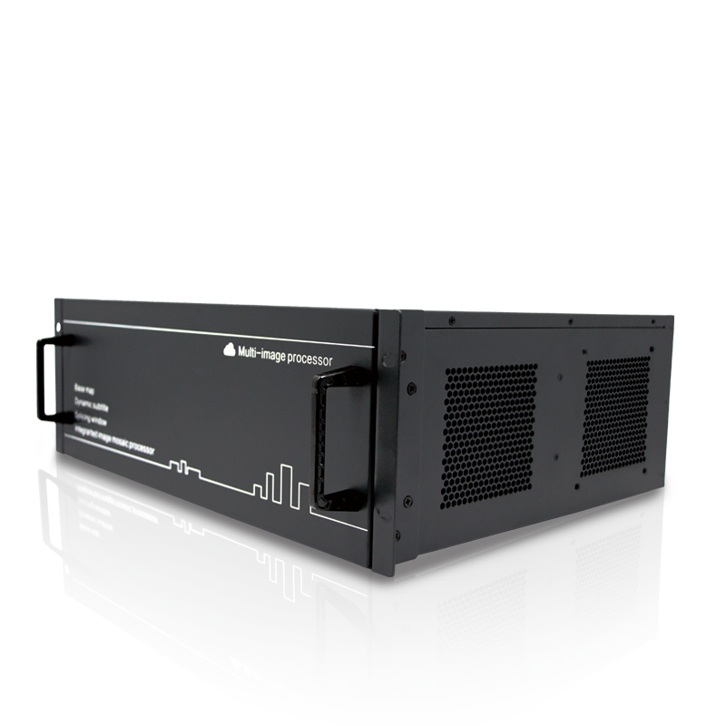

It is compatible with all standard ONVIF brand IPC decoding, and also supports the decoding and video playback of digital/analog video recorders such as HIKVISION, DaHua, UNIVIEW, XM, JOVISION, AEBELL, AEVISION, KEDACOM and TVT. With strong compatibility and flexibility, it can be widely used in supermarkets, shops, office buildings, residential areas, schools, hotels, factories and other monitoring sites.

**Product Performance**

* Average 6 Seconds start time and start and use.
* Equipped with Linux system, system stability, low power consumption, support 7*24 hours longtime and stable operation
* Modular plugged card design, Service CARD is plug-in card, very convenient for daily use and maintenance
* Input interface supports HDMI/VGA/DVI/BNC/SDI and output interface supports HDMI/DVI
* Support hardware reset
* A single signal can be tiled displayed on any of M×N(>0) units
* Support input signals to arbitrarily mosaic, window and roam, support layers overlay, single screen supports two image layers
* Intelligent scaling technology, image scaling using intelligent multi-phase filtering algorithm, according to the characteristics of the image automatically select the optimal filtering coefficient, image close to the order of magnitude; infinite scaling effect, more detail, non-jagged edge and good sharpness.
* Support the LED scrolling captioning function. The LED captioning needs to occupy one layer.
* Unified management of multi-platform client, automatic detection of input and output signals and Service CARD
* Single window supports maximum 36 screen segmentation with IP decoding Service CARD.
* IP stream decodes in real time, which supports H.264/H.265 decoding, supports ONVIF, RTSP and other network streaming media protocol, and is compatible with the main brand network camera (IPC), NVR, video streaming media server.
* A single network port supports decoding of maximum of 72-channel D1/32 channel 720P/18 channel 1080P/4 channel 4K.
* Support power recovery function and scene memory function
* Support pre-monitor and echo function, support multiple consoles to view different input videos

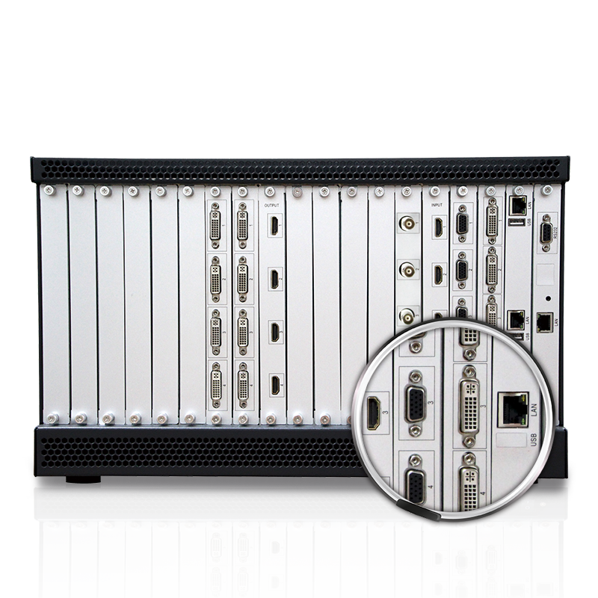

**IP Decoding Service CARD**

With a webcam, the IP decodingService CARD can be extended. A single network port can decode the 72-channel IPC at the same time, and the video of each camera can be transferred to any window position on the screen for display.

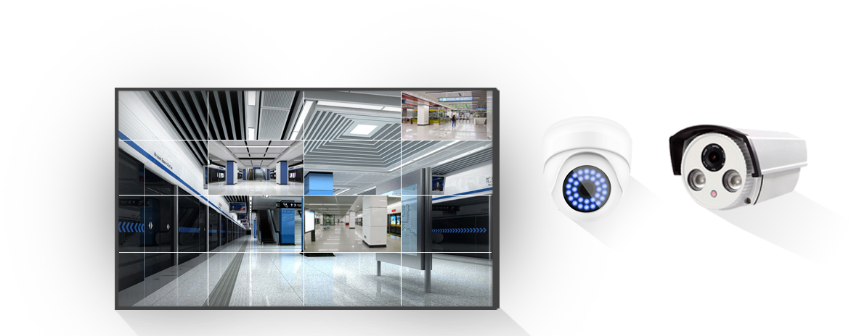

The image above is the actual-effect picture of the IP decoding Service CARD decoding 1080P. The camera can be dragged to other display units arbitrarily. The actual-effect picture is as followed.

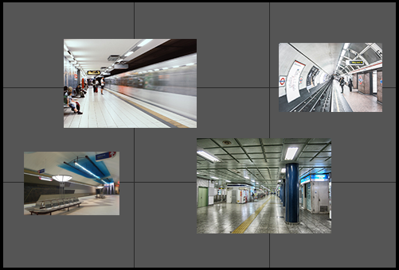

**IP Decoding Service CARD Effect Picture**

Based on mentioned functions and data analysis of video, sensitive video can be monitored in real time. Special situations can be displayed in a specific display area immediately, which facilitates the command of the situation on the scene.

Pre-monitor and Echo Service CARD

A console is used to see the input video to control the input video source at any time, which extended Pre-monitor and Echo Service CARD can make happen. One Service CARD supports 8-way simultaneous pre-monitoring video and supports 2 HDMI outputs.

The two monitors followed are connected to the output HDMI of the Pre-monitor and Echo Service CARD, and the figure below is the output image of the pre-monitor.

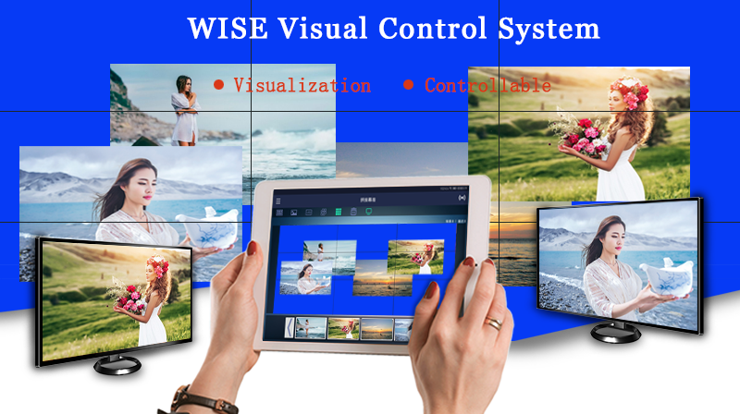

**Echo Function Actual-Effect Image in Platform Software**

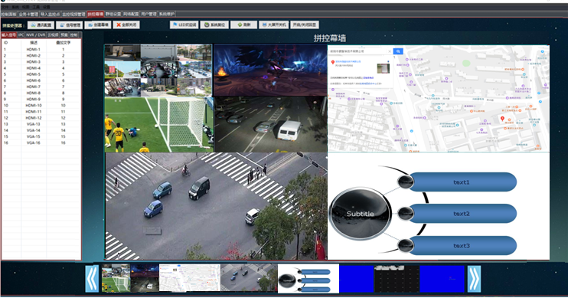

**Multimedia Miracast Service CARD**

It is usually used in the conference. Mobile devices such as mobile phones, tablets or laptops are connected to WiFi. With the help of central control system, the content in the mobile devices is projected onto the screen (splicing screen or CCTV wall) in real time.

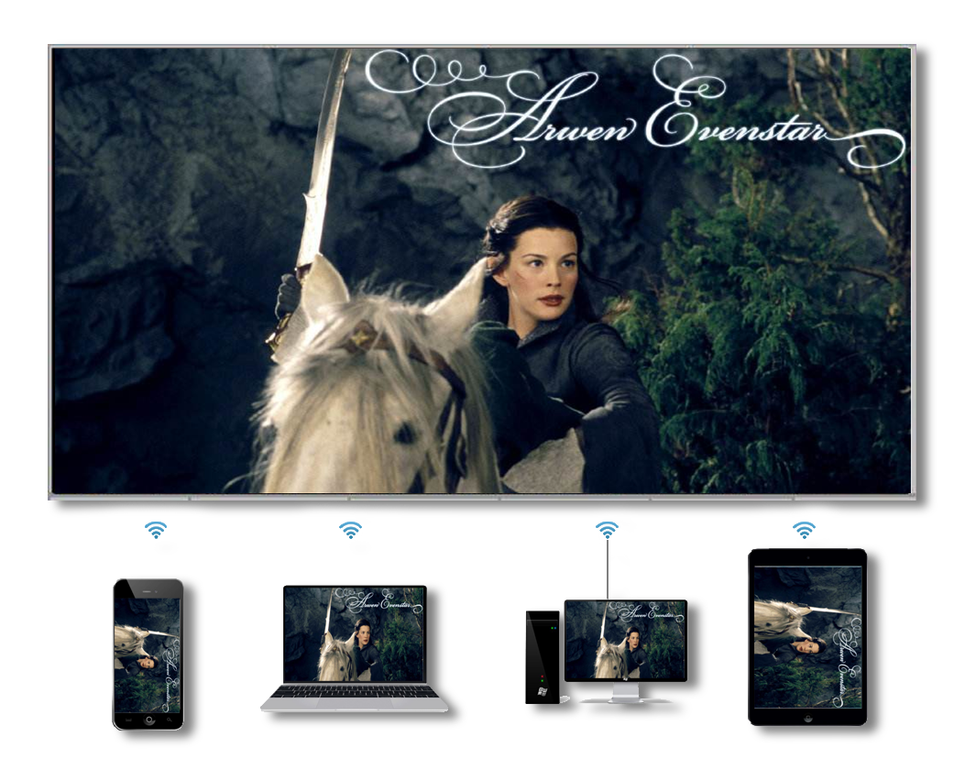

**Actual-Effect Image of Miracast**

**机箱尺寸 Size of Case**

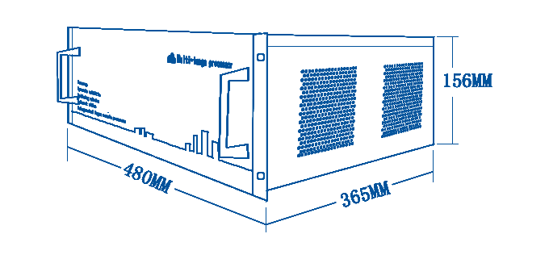

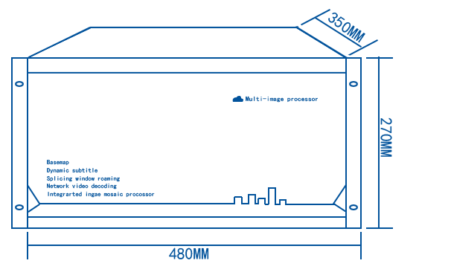

**物理接口 Physical Interface**

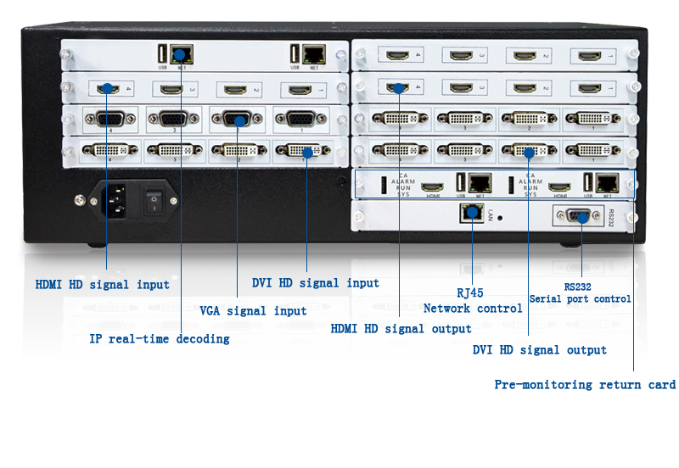

DVI HD Signal Input

RJ45 Network Control

HDMI HD Signal Input

VGA Signal Input

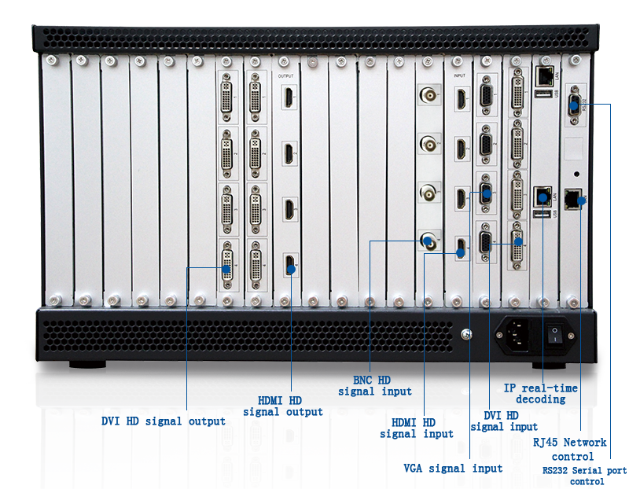

**Technical Parameters**

|  |  |  |  |  |  |  |
| --- | --- | --- | --- | --- | --- | --- |
| **Category** | Chassis Model | 3U Std | 6U Std | | 12U Std | |
| **Case Size** | Input Slot | 4 | 9 | | 18 | |
| Output Slot | 5 | 9 | | 18 | |
| Master Slot | 1 | 1 | | 1 | |
| Maximum Input/Output | 16 Input 20 Output | 36 Input 36 Output | | 72 Input 72 Output | |
| Network Control | Standard | | | | |
| RS232 Communication | Standard | | | | |
| Tablet Control | Support for Android | | | | |
| PC Client Control | Standard Windows graphical splicing control software  easy to use | | | | |
| **Video Input**  **(optional)** | Input Service CARD | Support 4 channels HDMI/DVI/SDI signal input, HDMI Type A interface/DVI-I interface, support HDC，BNC，etc., with maximum resolution 1920*1080@60Hz | | | | |
| **Video Output**  **(optional)** | Output Service CARD | Veneer 2 channels output, DMI Type A interface/DVI-I interface, support HDMI1.3 and digital signal protection protocol HDCP, etc., with maximum resolution 1920*1080@60Hz | | | | |
| **Pre-monitor and Echo CARD (optional)** | **Pre-monitor and Echo CARD** | Single card supports 8 channels of echo and pre-monitoring at the same time, and all input signal sources can be pre-monitored by switching. | | | | |
| **IP Video Decoding Card(optional)** | Network Camera Video Stream Input | Support 1 channel 1000M input, single internet access supports 18 channel 1080P, 32 channel 720P, 72 channel D1 video decoding, support H.264 and H.265 video compression format | | | | |
| **Basic Parameters** | Matrix Switch | With matrix function, the processor can switch any input signal to any output. | | | | |
| Images Splicing | Support mosaics and combination, support screen window, roaming and zooming, etc. | | | | |
| Image Segmentation | IPC network signal supports maximum 36 segmentation per window | | | | |
| Map Mode | Support ultrahigh resolution overlay display of static image. When the bottom image is open, the lowest window channel is occupied by default. Base map display supports three modes: single screen display for all screens, splicing display for all screens and splicing display for parts of contiguous area | | | | |
| HD Vector Subtitles (optional) | Ultra HD point to point vector subtitles, support dynamic and static subtitle, and you can edit the display content, font, color and other parameters | | | | |
| No Black Field Real-Time Switch | Black field and flower screen do not occur when signal is switched | | | | |
| Automatic Detection of Input and Output Board | Real-time detection of all inserted boards in the current processor | | | | |
| Automatic Detection of Input Signal | Real-time detection of input signal access in each channel, which is indicated in input board and client software | | | | |
| Power | 100W power adapter | | 200W power adapter | | 350W power adapter |
| Operation temperature/humidity | Operation temperature: -10°C ~ 50°C / relative humidity: 5°C ~ 95°C without condensation | | | | |
| Size | Width x Depth x Height (mm)  480x365x156 | | Width x Depth x Height (mm)  480x350x270 | | Width x Depth x Height (mm)  480x365x623 |
| Weight | <=20KG(full) | | <=35KG(full) | | <=70KG(full) |

**System Topology**

